**Introduction:**

Mulligan server will control the Mulligan parking app database and content .

All users will be connected to the server via internet ,

The database will contain all users data.

**How and where the data will be stored:**

All users data will be stored in the server in database , we will use MangoDB for this task , the database will be filled by Jason file that can be chosen in server GUI .

**how the server will operate:**

1. **Logging in :**

when users logging in the app , the app will connect to the server via internet and send the vehicle id to the server,

the server will check in the database if the vehicle id exists , if yes , server send the ok for the app , if not server sends connection request failed to the app .

1. **User Start parking :**

* when user hit “Start Parking” button in his app , the app will check if the user already has a parking event, if yes , the server will send to app that this user already has a parking event, if not , the server will start new parking event for the user.
* when starting a parking event, the server will store all running event users in local table in the database under “running parking events” table, that way the server can check which users already has a parking event running.

1. **User Stop parking:**

when user hit the “Stop Parking button”, the app will send to the server that the user want to end his parking, the server will check in the database if the user has event running, if yes, the event will stop running, if no, the server will return to the app that the users has no event running.

1. **User View Parking History:**

* when user press “Get Parking Events List”, the server will check all user parking history in the stored database and return them to the app to display them.
* all parking history will be stored in the database under “parking history” table.

1. **PEO check vehicle :**

If officer want to check the car if it parking illegally, When he press the “Check Vehicle” , the server will check in the database if the car has a running event(already exists in running parkings table) / parking legally , if yes , the server will return “Parking OK” to the app , if no the server will return appropriate error message to the app.

* Current time and date,vehicle id ,parking space-id , response will be stored in system log.

1. **Municipality officer search:**

If the officer search for vehicle id/parking space record , and he press “Check Vehicle” ,the server will get space id , start time and stop time , server will return “Parked ok” if the parking was ok , if not the server will return appropriate error message to the app.

* Current time and date,vehicle id ,parking space-id , response will be stored in system log.

**Server log:**

The server log will be created locally in “ServerLog” file, PEO and MO operations on the database /server will be stored in the log, this way we can debug and see if the server is working with no issues.

**Connection ways:**

1. All clients apps will be connected to the server via internet.
2. The apps will read/ write to the server via socket.

**Mulligan Server Gui User Guide:**

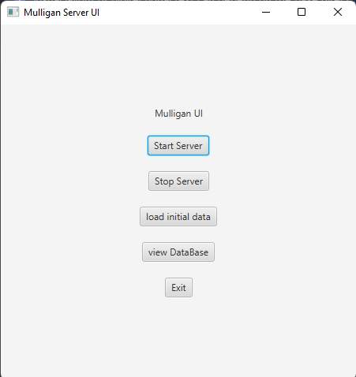

**Gui Buttons :**

1. "Start Server" button: The button will start the Server.
2. "Stop Server" button: The button will stop the Server.
3. "load initial data" button: The button will load a JASON file that contains users data to the Database.
4. "view Database" button: The button will view the Database data.
5. "Exit" button: The button will close the GUI.